

Problem Solving with Programming

**Computer Science & Engineering**

**By**

Roll. No : 2103A51073 Name: T. Manikanta Sai

Roll.No:2103A51080 Name: B. Anil Kumar

Roll. No: 2103A51553 Name: E. shruthi

Roll. No: 2105A41030 Name: Aseen

**Under the Guidance of**

**Dr.P.Praveen**







PSP-PROJECT

TOPIC-ONLINE MOVIE TICKET BOOKING

SECTION-A2(BATCH-02)

|  |  |
| --- | --- |
| CONTENTS | Pg.no |
| 1. ABSTRACT 2. INTRODUCTION 3. MODULES DESCRIPTION 4. IMPLEMENTATION 5. TEST RESULTS 6. CONCLUSION 7. FUTURE SCOPE | 3  4-5  6-9  10-21  22-23  24  25 |

ONLINE MOVIE TICKET BOOKING

**1.ABSTRACT:**



The project objective is to book cinema tickets in online. The Ticket Reservation System is an Internet based application that can be accessed throughout the Net and can be accessed by anyone who has a net connection. This application will reserve the tickets. This online ticket reservation system provides a website for a cinema hall where any user of internet can access it. User is required to login to the system and needs a credit card for booking the tickets. Tickets can be collected at the counter. But all this excitement vanishes after standing in hours in long queues to get tickets booked. The website provides complete information regarding currently running movies on all the screens with details of show timings, available seats. Ticket reservations are done using credit card and can be cancelled if needed. Our online tickets reservation system is one of the best opportunities for those who cannot afford enough time to get their tickets reserved standing in long queues. People can book tickets online at any time of day or night. Our reservation system also provides option to cancel the tickets which are reserved previously

The project objective is to book cinema tickets in online. The Ticket Reservation System is an Internet based application

that can be accessed throughout the Net and can be accessed by anyone who has a net connection. This application will reserve the

tickets. This online ticket reservation system provides a website for a cinema hall where any user of internet can access it. User is

required to login to the system and needs a credit card for booking the tickets. Tickets can be collected at the counter and

Watching movies with family and friends in theatres is one of the best medium of entertainment after having a hectic schedule. But

all this excitement vanishes after standing in hours in long queues to get tickets booked. The website provides complete

information regarding currently running movies on all the screens with details of show timings, available seats. Ticket reservations

are done using credit card and can be cancelled if needed. Our online tickets reservation system is one of the best opportunities for

those who cannot afford enough time to get their tickets reserved standing in long queues. People can book tickets online at any

time of day or night. Our reservation system also provides option to cancel the tickets which are reserved previously

The project objective is to book cinema tickets in online. The Ticket Reservation System is an Internet based application

that can be accessed throughout the Net and can be accessed by anyone who has a net connection. This application will reserve the

tickets. This online ticket reservation system provides a website for a cinema hall where any user of internet can access it. User is

required to login to the system and needs a credit card for booking the tickets. Tickets can be collected at the counter and

Watching movies with family and friends in theatres is one of the best medium of entertainment after having a hectic schedule. But

all this excitement vanishes after standing in hours in long queues to get tickets booked. The website provides complete

information regarding currently running movies on all the screens with details of show timings, available seats. Ticket reservations

are done using credit card and can be cancelled if needed. Our online tickets reservation system is one of the best opportunities for

those who cannot afford enough time to get their tickets reserved standing in long queues. People can book tickets online at any

time of day or night. Our reservation system also provides option to cancel the tickets which are reserved previous

**2**.**INTRODUCTION** :

**2.INTRODUCTION:**

2.INTRODUCTION:

**C Language:**



C is a [general-purpose](https://en.wikipedia.org/wiki/General-purpose_language) computer [programming language](https://en.wikipedia.org/wiki/Programming_language). It was created in the 1970s by [Dennis Ritchie](https://en.wikipedia.org/wiki/Dennis_Ritchie), and remains very widely used and influential.By design, C's features cleanly reflect the capabilities of the targeted CPUs. It has found lasting use in [operating systems](https://en.wikipedia.org/wiki/Operating_system), [device drivers](https://en.wikipedia.org/wiki/Device_drivers), [protocol stacks](https://en.wikipedia.org/wiki/Protocol_stack),though decreasingly for [application software](https://en.wikipedia.org/wiki/Application_software), and is common in computer architectures that range from the largest [supercomputers](https://en.wikipedia.org/wiki/Supercomputer) to the smallest

[microcontrollers](https://en.wikipedia.org/wiki/Microcontroller) and [embedded systems](https://en.wikipedia.org/wiki/Embedded_system).

A successor to the programming language [B](https://en.wikipedia.org/wiki/B_(programming_language)), C was originally developed at [Bell Labs](https://en.wikipedia.org/wiki/Bell_Labs) by [Dennis Ritchie](https://en.wikipedia.org/wiki/Dennis_Ritchie) between 1972 and 1973 to construct utilities running on [Unix](https://en.wikipedia.org/wiki/Unix). It was applied to re-implementing the kernel of the Unix operating system. During the 1980s, C gradually gained popularity. It has become one of the [most widely used programming languages](https://en.wikipedia.org/wiki/Measuring_programming_language_popularity), with C [compilers](https://en.wikipedia.org/wiki/Compiler) available for almost all modern [computer architectures](https://en.wikipedia.org/wiki/Computer_architecture) and operating systems. C has been standardised by [ANSI](https://en.wikipedia.org/wiki/American_National_Standards_Institute) since 1989 ([ANSI C](https://en.wikipedia.org/wiki/ANSI_C)) and by the [International Organization for Standardization](https://en.wikipedia.org/wiki/International_Organization_for_Standardization) (ISO).

Welcome to newly designed website movie ticket booking is a faster, cleaner and a tad more personal website, specially designed to make your booking experience better. Log on, navigate and find out for yourselves and if time permits leave your valuable feedback. Customers may view the contents of any movie show at any time and may book any movie ticket as needed. The program automatically calculates the subtotal and grand total. When a visitor decides to finally book the ticket, the order information including the buyer's name, address and billing instruction is stored in the database securely and payment has been made. The combo booking is also provided at the time of booking the ticket and there’s a wonderful facility of delivering the combos at your seat when you are watching the movie. You need to register a new user whenever you have first visited or site then for future it will be stored in our database permanently and you can book you movie ticket at any time you want with this username and password.

**3.Modules/Libraries included:**

In this code we have used functions and structures :

FUNCTIONS:

* movie()
* theatre()
* timings()
* noofseats()
* billing()
* Exit()

There are several advantages of using functions in our code

> It enhances the readability of a program

> It made easy to understand

> Reduces complexity of program and gives it a modular structure

> By implementing functions and procedures in this program, the programmer reduces coding time and debugging time, thereby reducing the overall development time.

>For Online movie ticket booking in C language we use Three libraries which are included using the preprocessor directive #include.

1. **Stdio.h**:

printf : It is used to print the strings, integer, character etc on the output screen.

scanf : It reads the character, string, integer etc from the keyboard.

puts : It is used to write a line or string to the output stream that is upto ,but not include the null character.

fclose : It close the opened file

fopen : It opens the file and all file handling functions are defined in stdio.h header file.

fscanf : This function is used to read the formatted input from the given stream in c language.

fprintf : This function writes and formats the output stream. It is used to print the message but not on stdout console.

1. **Stdconio.h** :

**conio.h**: has many built in functions that are used to perform input and output functions from a c program.

**getch** : Avoids echo and takes characters directly from the console.

**putch** : Place the character on the console.

3.**Stdlib.h :**

The stdlib.h stands for standard library header file. It has the information of memory allocation/freeing functions. To make a tic-tac-toe game we particularly use the system() function to clear the output window.

Here is the table that displays some functions in stdlib.h in C language,

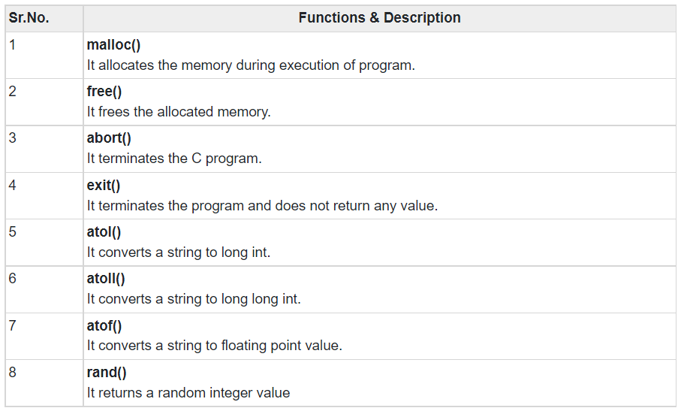

**Syntax:**



**Example:**



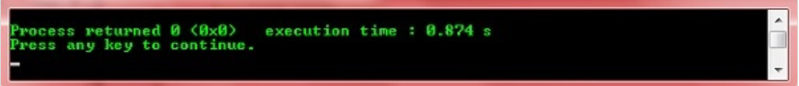

4.IMPLEMENTATION:

#include<stdio.h>

#include<conio.h>

#include<stdlib.h>

void movie();

void theatre();

void timings();

void noofseats();

void billing();

void Exit();

void main()

{

movie();

}

void movie()

{

int i,flag=0;

printf("\n||=======================================================================||");

printf("\n|| ||");

printf("\n|| Welcome to Online Moive Ticket Booking ||");

printf("\n|| ||");

printf("\n||=======================================================================||\n");

//printf("\t\t MOVIE TICKETS BOOKING");

printf("\n||-----------------------------------------------------------------------||");

printf("\n|| Movies Available ||");

printf("\n||-----------------------------------------------------------------------||");

printf("\n|| Press [1]: Alavaikuntapuramulo ||");

printf("\n|| Press [2]: Sarileru Nikevaru ||");

printf("\n|| Press [3]: Mahanati ||");

printf("\n|| Press [4]: Happy days ||");

printf("\n|| Press [5]: Sainikudu ||");

printf("\n|| Press [6]: Exit ||");

//printf("\n1.Alavaikuntapuramulo\n2.sarileru nikevaru\n3.Mahanati\n4.Happy days\n5.sainikudu");

printf("\n||=======================================================================||");

printf("\n Enter your choice:");

//printf("\n||=======================================================================||");

scanf("%d",&i);

if(i==1)

{

printf("\n||-----------------------------------------------------------------------||");

printf("\n|| Alavaikuntapuramulo ||");

printf("\n||-----------------------------------------------------------------------||");

}

else if(i==2)

{

printf("\n||-----------------------------------------------------------------------||");

printf("\n|| sarileru nikevaru ||");

printf("\n||-----------------------------------------------------------------------||");

}

else if(i==3)

{

printf("\n||-----------------------------------------------------------------------||");

printf("\n|| Mahanati ||");

printf("\n||-----------------------------------------------------------------------||");

}

else if(i==4)

{

printf("\n||-----------------------------------------------------------------------||");

printf("\n|| Happy Days ||");

printf("\n||-----------------------------------------------------------------------||");

}

else if(i==5)

{

printf("\n||-----------------------------------------------------------------------||");

printf("\n|| Sainikudu ||");

printf("\n||-----------------------------------------------------------------------||");

}

else

do{

{

if(i=='6')

flag=1;

}

}while(flag==0);

/*else

{

printf("Enter correct number");

}*/

theatre();

}

void theatre()

{

int a,flag=0;

printf("\n||=======================================================================||");

printf("\n|| Theatres ||");

printf("\n||=======================================================================||");

printf("\n|| Press [1]: Asian Mall(Screen 2) ||");

printf("\n|| Press [2]: Ashoka ||");

printf("\n|| Press [3]: Vijayatalkies ||");

printf("\n|| Press [4]: S2(Screen 4) ||");

printf("\n|| Press [5]: Amurutha ||");

printf("\n|| Press [6]: Exit ||");

printf("\n||-----------------------------------------------------------------------||");

//printf("\n1.Asian mall\n2.Sridevi\n3.Vijayatalkies\n4.S2\n5.Exit");

printf("\n Enter your choice:");

//printf("\nEnter your choice:");

scanf("%d",&a);

if(a==1)

{

printf("\n||-----------------------------------------------------------------------||");

printf("\n|| Asian mall(Screen 2) ||");

printf("\n||-----------------------------------------------------------------------||");

}

else if(a==2)

{

printf("\n||-----------------------------------------------------------------------||");

printf("\n|| Ashoka ||");

printf("\n||-----------------------------------------------------------------------||");

}

else if(a==3)

{

printf("\n||-----------------------------------------------------------------------||");

printf("\n|| Vijayatalkies ||");

printf("\n||-----------------------------------------------------------------------||");

}

else if(a==4)

{

printf("\n||-----------------------------------------------------------------------||");

printf("\n|| S2(Screen 4) ||");

printf("\n||-----------------------------------------------------------------------||");

}

else if(a==5)

{

printf("\n||-----------------------------------------------------------------------||");

printf("\n|| Amurutha ||");

printf("\n||-----------------------------------------------------------------------||");

}

else

do{

{

if(a=='6')

flag=1;

}

}while(flag==0);

/*else

{

printf("\nEnter correct number");

}*/

timings();

}

void timings()

{

int y,flag=0;

printf("\n||=======================================================================||");

printf("\n|| Timings ||");

printf("\n||=======================================================================||");

printf("\n|| Press [1]: Morning Show ||");

printf("\n|| Press [2]: Matinee Show ||");

printf("\n|| Press [3]: Evening show ||");

printf("\n|| Press [4]: Night show ||");

printf("\n|| Press [5]: Exit ||");

printf("\n||-----------------------------------------------------------------------||");

//printf("\n1.Morning show\n2.Matinee\n3.Evening show\n4.Night show\n5.Exit");

printf("\n|| Enter your choice: ");

scanf("%d",&y);

if(y==1)

{

printf("\n||-----------------------------------------------------------------------||");

printf("\n|| Morning show(9:30am to 12:30pm) ||");

printf("\n||-----------------------------------------------------------------------||");

}

else if(y==2)

{

printf("\n||-----------------------------------------------------------------------||");

printf("\n|| Matinee show(2:30pm to 5:30pm)");

printf("\n||-----------------------------------------------------------------------||");

}

else if(y==3)

{

printf("\n||-----------------------------------------------------------------------||");

printf("\n|| Evening show(6:30pm to 9:00pm) ||");

printf("\n||-----------------------------------------------------------------------||");

}

else if(y==4)

{

printf("\n||-----------------------------------------------------------------------||");

printf("\n|| Night show(9:30pm to 12:30am) ||");

printf("\n||-----------------------------------------------------------------------||");

}

else

do{

{

if(y=='5')

flag=1;

}

}while(flag==0);

/*else

{

printf("Enter correct number");

}*/

noofseats();

}

void noofseats()

{

int z,b,n,flag=0;

printf("\n||=======================================================================||");

printf("\n|| Enter no.of seats to book:");

scanf("%d",&z);

b=200*z;

n=100-z;

printf("\n||=======================================================================||");

printf("\n|| Total cost=%d",b);

printf("\n||=======================================================================||");

printf("\n No.of seats available :%d\n",n);

billing();

}

void billing()

{

int seats,mb_no;

char name,row,movie_name;

float cost,tot_amt;

printf("\n\t\t *** Billing ***");

printf("\n||=======================================================================||");

printf("\n Enter Name:\t");

scanf("%s",&name);

printf("\n Enter Mobile Number:\t");

scanf("%d",&mb_no);

printf("\n Enter Movie Name:\t");

scanf("%s",&movie_name);

printf("\n Enter Row:\t");

scanf("%s",&row);

printf("\n Enter Total No Of Seats:\t");

scanf("%d",&seats);

printf("\n Enter Cost Per Ticket:\t");

scanf("%f",&cost);

printf("\n Enter Total Amount:\t");

scanf("%f",&tot_amt);

printf("\n||=======================================================================||");

printf("\nTckets Booked successfully!!!\n*** ENJOY MOVIE ***");

}

**5.TEST RESULTS:**

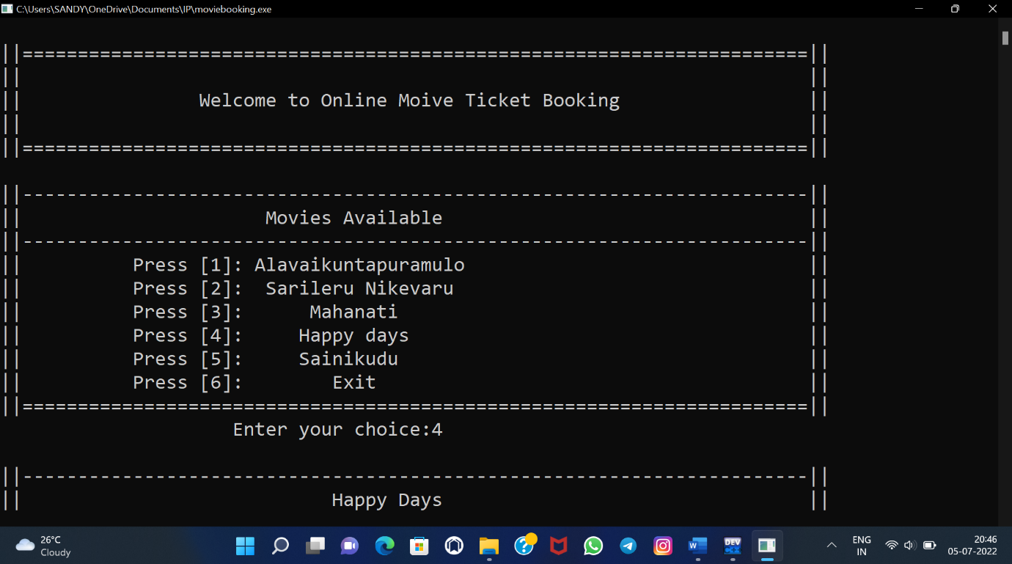

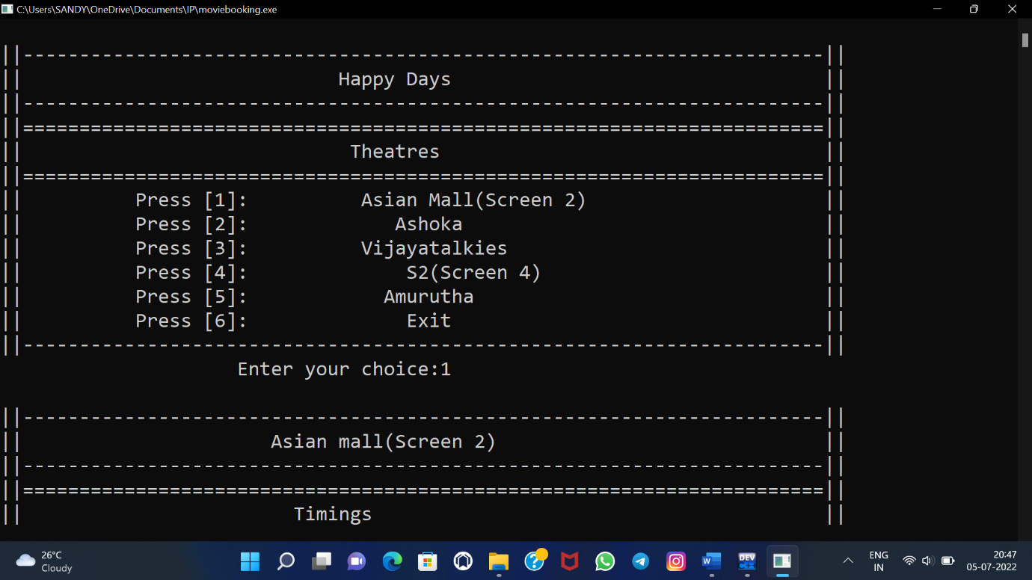

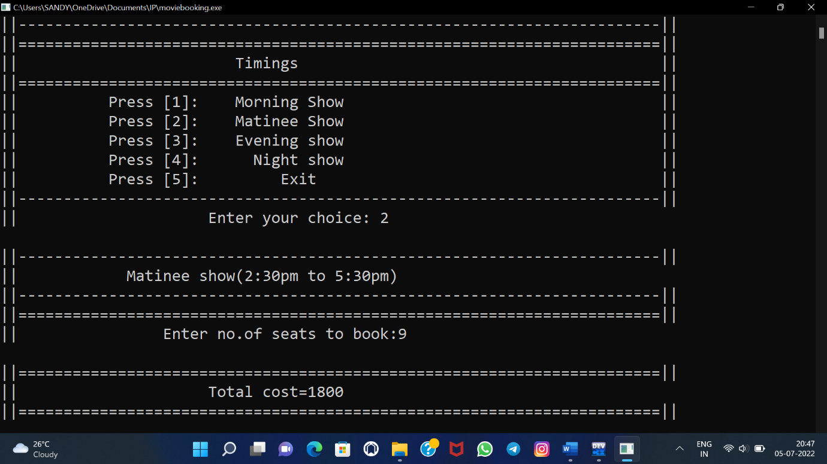

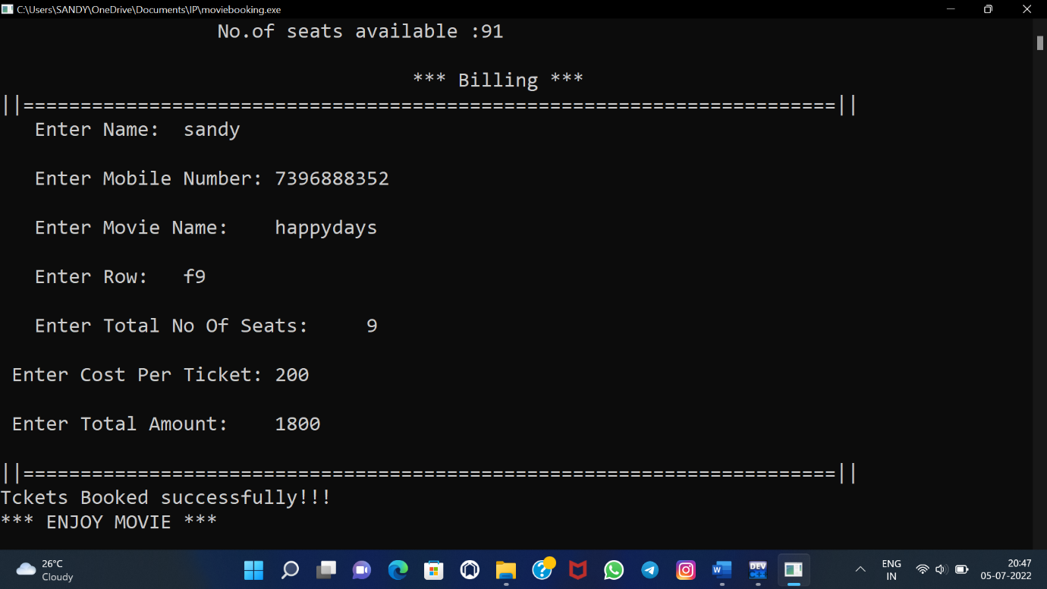

**6.CONCLUSION:**

This project is developed successfully and the performance is found to be satisfactory. This project is designed to meet the requirements of assigning jobs.

The user will be able to book the ticket using this website. The relationship between company manager, employee, and customer satisfy a good communication to complete ticketing process.

We have designed the project to provide the user with easy retrieval of data, details of theatre and necessary feedback as much as possible. In this project, the user is provided with a website that can be used to book movie tickets online. To implement this as a web application we used C programming as the technology

**7.FUTURE SCOPE:**

• In future our job management system will have extra facilities and more companies for more employees.

• It will grant more easy access.

• We are going to include recommendation system to this project so it will be help full for the user to search and apply for jobs as they wish.

_____ **THANK YOU____**